**Cameron Robinson**

**Final Report**

Elastic Disaster Recovery

(AWS)

# Contents

Deliverables and Tentative Schedule…………………………………………………………………………………………….4/5

Project Status and Progress……………………………………………………………………………………………………………4/5

Project Summary……………………………………………………………………………………………………………………………5/6

Creation of AWS Account……………………………………………………………………………………………………………….6

AWS region ……………………………………………………………………………………………………………………………………7

Creation of EC2 instance ……………………………………………………………………………………………………………………………………………………….7

Payment method .………………………..……………………………………………………………………………………………………………………….……8

Implementing Replication Server…………………….……………………………………………………………………………………………………………….………9

Replication server instance type …………………………………………………………………………………………….…….10

Volumes and security groups ……………………………………………………………………………………………………….11

Additional replication settings……………………………………………………………………………………………………….12

Replication server created ……………….………………………………… .………………………………………………………13

IAM user creation …………………..…………………………………….…………………………………………………………………………………….…….14

Setting policies in IAM user…………………………….…………………………… ……………………………………………….15

Reviewing IAM user & adding tags ……………………………………………………………………….……………………………………………………………………..………16

Access key creating ………………………………………………………….……………………………………………………………17

IAM user created with policies attached…………………………………………………………………………………….… 18

IAM role creation with policies attached……….………………………………………………………….……………….… 19

IAM role attached to EC2 …….…………………………………………………………………….………………………………………………………………………… 20

Connect to EC2………. …………………………………………………………………………………………………………………….21

Amazon Linux….………. …………………………………………………………………………………………………………….…….22

Amazon Linux command prompt……………………………………………………………………………………………………………………………………….….23

Linux command prompt files……………………………………………………………..……………………………………………………………………………….24

Amazon Linux command instructions …………………………………………………………………………………………………………………………………………………….25

Amazon Linux Replication prompt…………………..…………………………………………………………………………………………………………………….26

Amazon Linux replication prompt successfully ……………………………….…………………………………………………………………………………………………………………….27

Amazon Linux replication prompt files ……………………………….…………………………………………………………………………………………………………………….28

Linux replication agent starting………………………………………………………………………………………………………………………………………….29

Linux replication access key………………………….…………………………………………………………………………………………………………………….30

Linux replicating disk ………………………………………………………………………………………………………………..….30

Roadblock: Installing agent failed ……………………………….……………………………………………………………………………………………………………….…….31

Roadblock resolution: Change instance storage type………………………..…………………………………………………………………………………………………………….……….31

Installing replication agent agent successfully ………………………………………………………………………………………………………..…………………………………………….32

Adding ec2 to Disaster recovery source server ……………………………………………………………………………………………………………………………………………..……….33

Elastic DR replication sever adding to EC2 instance …………………………………………………………………………………………………………………………………………………..….34

Initiating disaster recovery drill

…………………………………………………………………………………………………………………………………………………..….35

Recovery drill status

…………………………………………………………………………………………………………………………………………………..….36

Recovery job Initiation

…………………………………………………………………………………………………………………………………………………..….37

Recovery job successful

…………………………………………………………………………………………………………………………………………………..….38/39

# Deliverables and Tentative Schedule

|  |  |
| --- | --- |
| Deadline | Objective Schedule |
| Sep 15th | Create AWS account and signing into the Aws management console |
| Sep 20th | Creating an ec2 instance for the elastic recovery tool |
| Oct 1st | Implementing replication server |
| Oct 15th | Configuring replication server configuration |
| Nov 5th | Creating IAM user along with access keys |
| Nov 23rd | Project should be fully completed, and Final Report should be finished. |

# Project Status and Project Progress:

|  |  |
| --- | --- |
| **Status/Progress** | **Things I accomplished** |
| **Week 1** | I spent the first week of the creating my aws account for set up and |
| **Week 2** | I started by creating my AWS the instance. |
| **Week 3** | Set up payment method |
| **Week 4** | Implementing and configuring replication server |
| **Week 5** | Creating IAM user, setting policies, and creating access key |
| **Week 6** | Installing Replication agent to ec2 instance using Amazon Linux. |
| **Week 7** | Right now, I have successfully installed the Replication agent through Linux and will initiate my disaster recovery. |
| **Week 8** | Initiated a recovery drill. It is basically a test job to ensure that everything will be healthy and successful |
| **Week 9** | Initiated the recovery job. I was successful in doing so. |

|  |  |
| --- | --- |
| **Roadblock:** | Issue: The issue I have occurred is when trying to install the replication agent. I need to have 500MB root disk space. I have 475 MB so I have to extend the volume size in order to successfully install the agent. |
| **Roadblock Resolution:** | Resolution: In order to have the minimum storage in order to successfully install the Linux agent into my ec2. I needed to change my storage that was implanted on my ec2. Originally I use a free tier eligible which was a t2.micro with 1 GB and 475 MB. I have now changed the storage to a t2.large which has 8GB and 500+ MB. The minimum requirement for installing the agent needs to be 8GB and 500MB. |

For this project, I will be designing and deploying a cloud disaster recovery environment on AWS. With many organizations moving and working with the cloud. It is crucial to have a disaster recovery environment in case of any issues, so it prevents the cause of data loss and other important cases as well. It is important to understand how disaster recovery environments work and how effective they are in the world.

This project will ensure how this tool minimizes downtime and data loss with fast, reliable data recovery of on premises instances and cloud-based applications using affordable storage, minimal computing, and point in time recovery.

This project is designed to enhance my knowledge of AWS cloud management and data recovery skills in AWS. The project scope includes designing, implementing, creating, and configuring securing a cloud-based data disaster recovery tool housed on the Amazon Web Services (AWS) platform. This project will create a fast, reliable data recovery AWS environment by configuring Virtual Private Clouds, Identity and Access Management rules, security groups, volumes, policies, servers and instances

Alongside taking a deep dive into AWS services, this project will also aid in enhancing many soft skills needed as an IT professional such as problem solving, cloud configuration and data loss retrieval. I will use the services that are offered by AWS.

# Creation of AWS Account

**Figure 1: Account Creation**

### A screenshot of a computer Description automatically generatedDescription of AWS Account Creation:

* This was a very simple step. I just had to set up the account in AWS.

## Defining the project's AWS region



**Figure *2*: Region/AZ**

### Description of AWS Region:

* The region I decided to go with for my project is us-east-2. It is the default region and has all the services that I will need.

# Creation of EC2 instance

**Figure *3*: Ec2 Creation**

### Description of EC2 instance:

* In this screenshot, you will see the creation of my VPC named cam1. I will use this instance for my disaster recovery tool instead of me using a vpc already made.

# Payment method

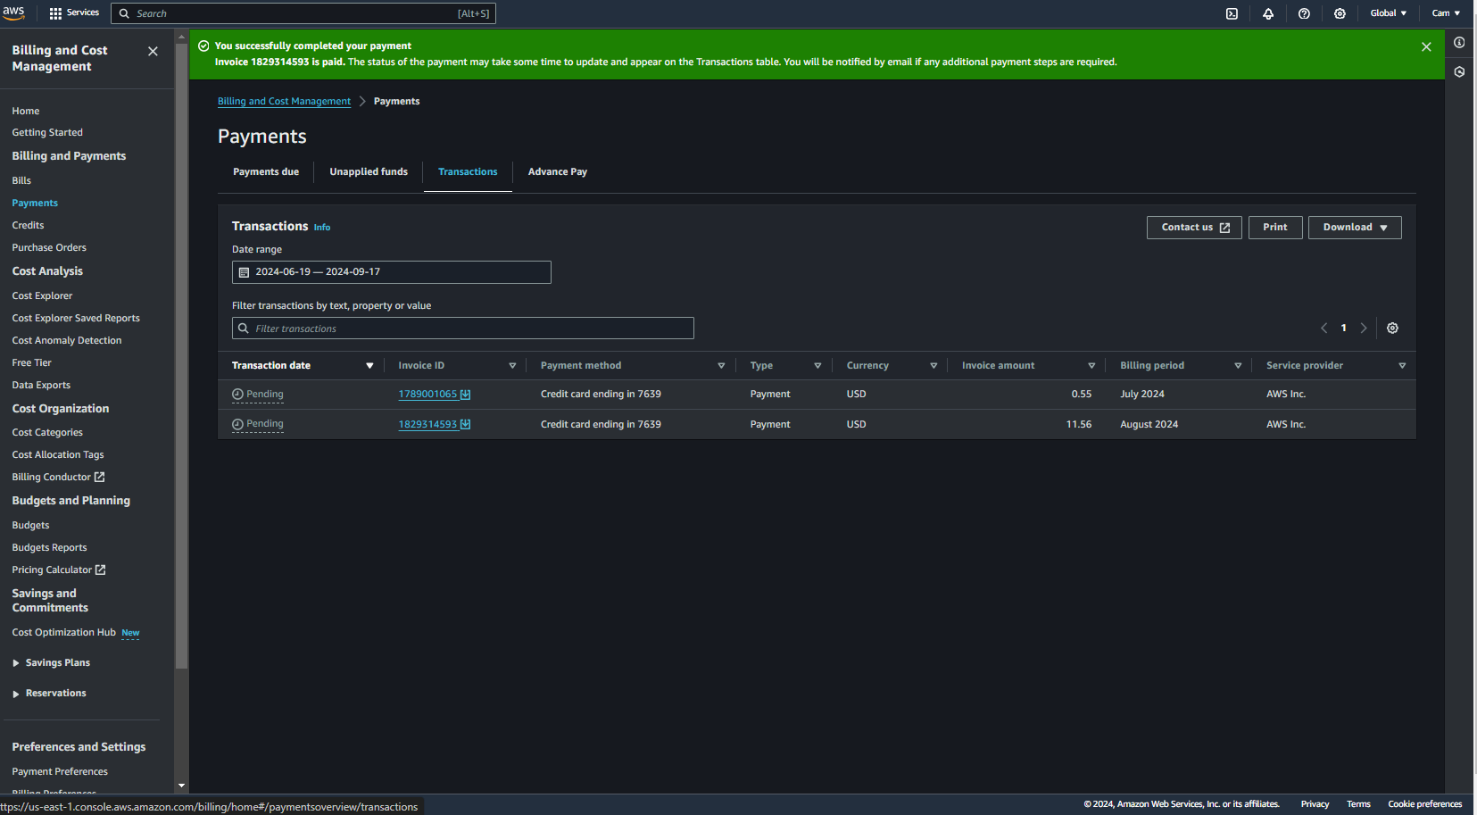

**Figure *4*: Payment method**

### Description of Payment method:

* This is a screenshot of the payments for my EC2. Using an ec2 is not free. This shows much each month the ec2 is being used monthly. I have added my card to the payment method as well.

Implementing Replication Server

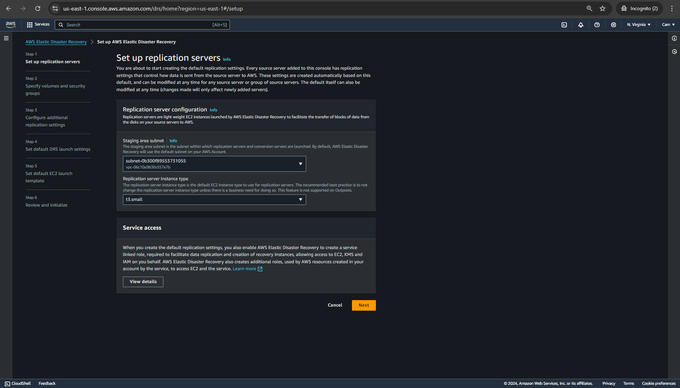

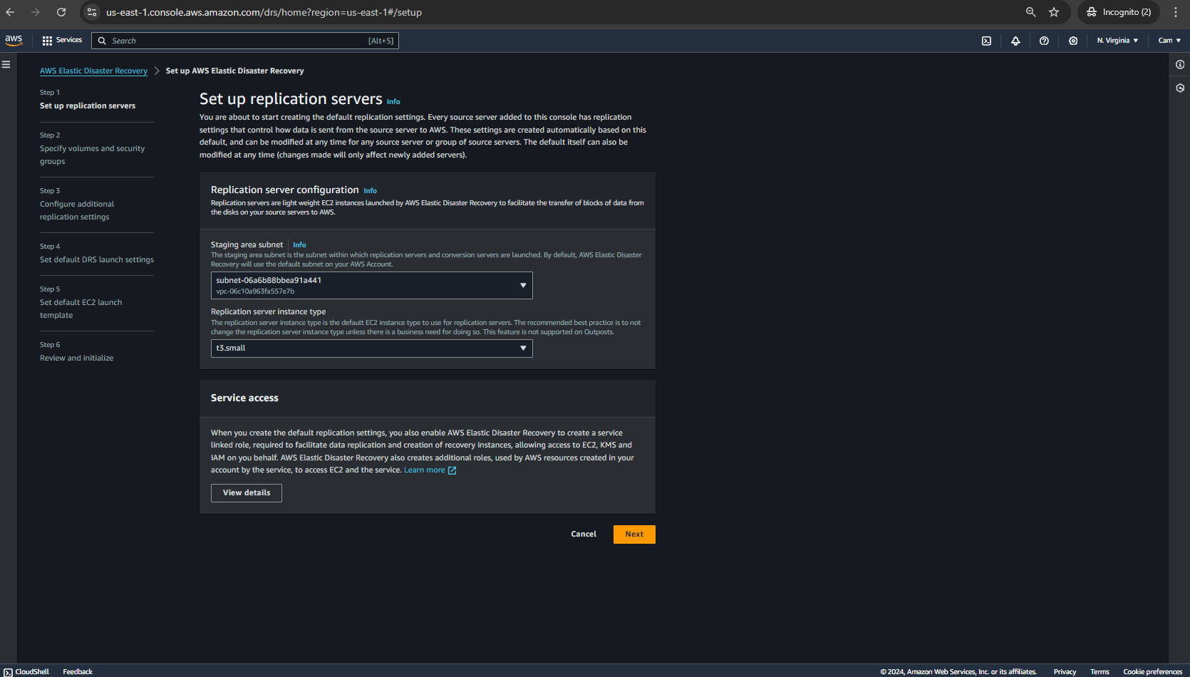

**Figure *5*: Implementing Replication Server**

Description of Implementing Replication Server:

* Here is me creating my replication server for my Elastic Disaster Recovery tool. In the second screenshot you will see a slight change in the subnet area. The subnets have changed because this is the same subnet that my vpc is given. So, this replication server will be used in my VPC.
* Setting up replication server instance type

**Figure *6*: Replication server instance type**

Description of replication server instance type:

* Above is where I selected my instance type for my replication server. Which will be t3.small for my EC2 instance.

Configuring Volumes and security groups

**Figure *7*: Volumes and security groups**

Description of Volumes and security groups:

* Above are the Is where I will be configuring the volumes for my disaster recovery tool.

Additional replication settings (PIT) policy and other

**Figure *8*: Additional Replication settings**

Description of additional replication settings:

* I will leave the data routing to a public IP address since I have set my ec2 to a public address. As well I set up the point in time policy to 7 days because there are 7 days in a week. For those 7 days I want the snapshot to load up data from the past 7 days.

Overlook of completion of replication Server

**Figure *9*: Replication server created**

Description of Replication server:

* Here is an overlook of the replication server that I have created for my disaster recovery tool. For the data to remain the same once I test the disaster recovery tool

# Creation of IAM user

**Figure *10*: IAM user**

Description of IAM user:

* As for now I am now creating an IAM user for my disaster recovery tool.

Selecting permission policies for the IAM user

**Figure *11*: IAM Policies**

Description of IAM Policies:

* Here is where I will be attaching the AWS elastic disaster Recovery agent installation policy for my IAM user. To run the disaster recovery tool, I must have this.

Reviewing IAM user & adding tags

**Figure *12*: Reviewing IAM user & adding tags**

Description of Reviewing IAM user & tags:

* Here is the overview of creating the IAM user. As well I have added a tag to my IAM as you can see in the screenshot.

Creating an Access key

**Figure *13*: Access key**

Description of Access key:

* I have created an access key for my IAM because when I install the policy to the elastic disaster in Linux. For security reasons, I have made this just so I will be the only one able to use it since I have access to the access keys.

IAM user created

**Figure *14*: IAM user created**

Description of IAM created:

* Here is an overlook of my IAM user that is created.

IAM role creation

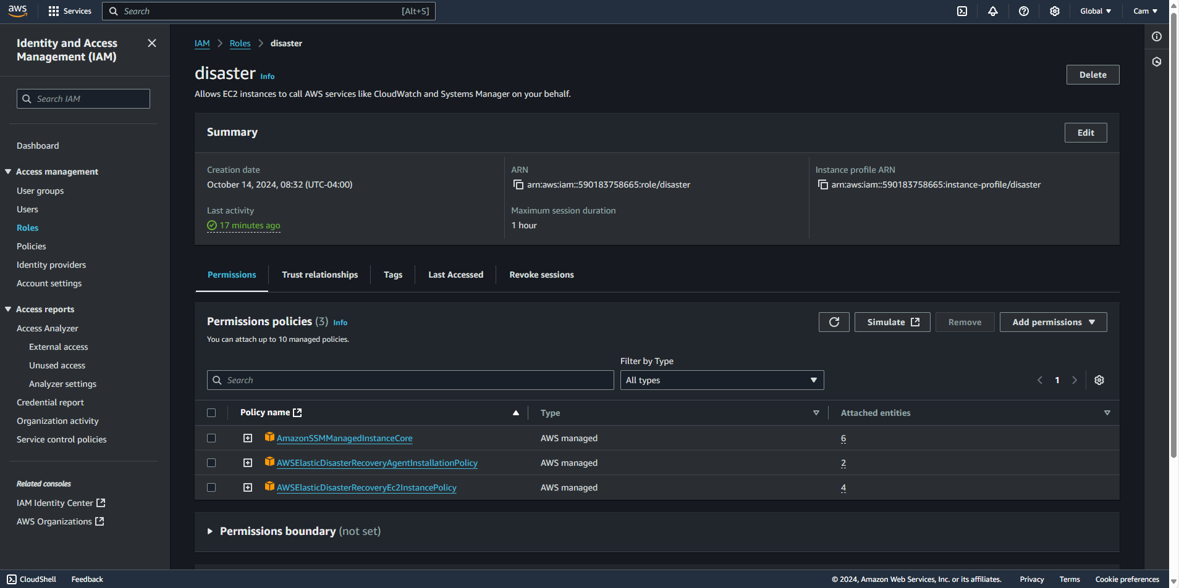

**Figure *15*: IAM role**

Description of IAM role created:

* Here is an overlook of my IAM role that was created. I needed to have this created so I can attach the policies needed for the disaster recovery tool. Here you the policies in the screenshot which is needed to successful install the replication agent.

IAM role attached

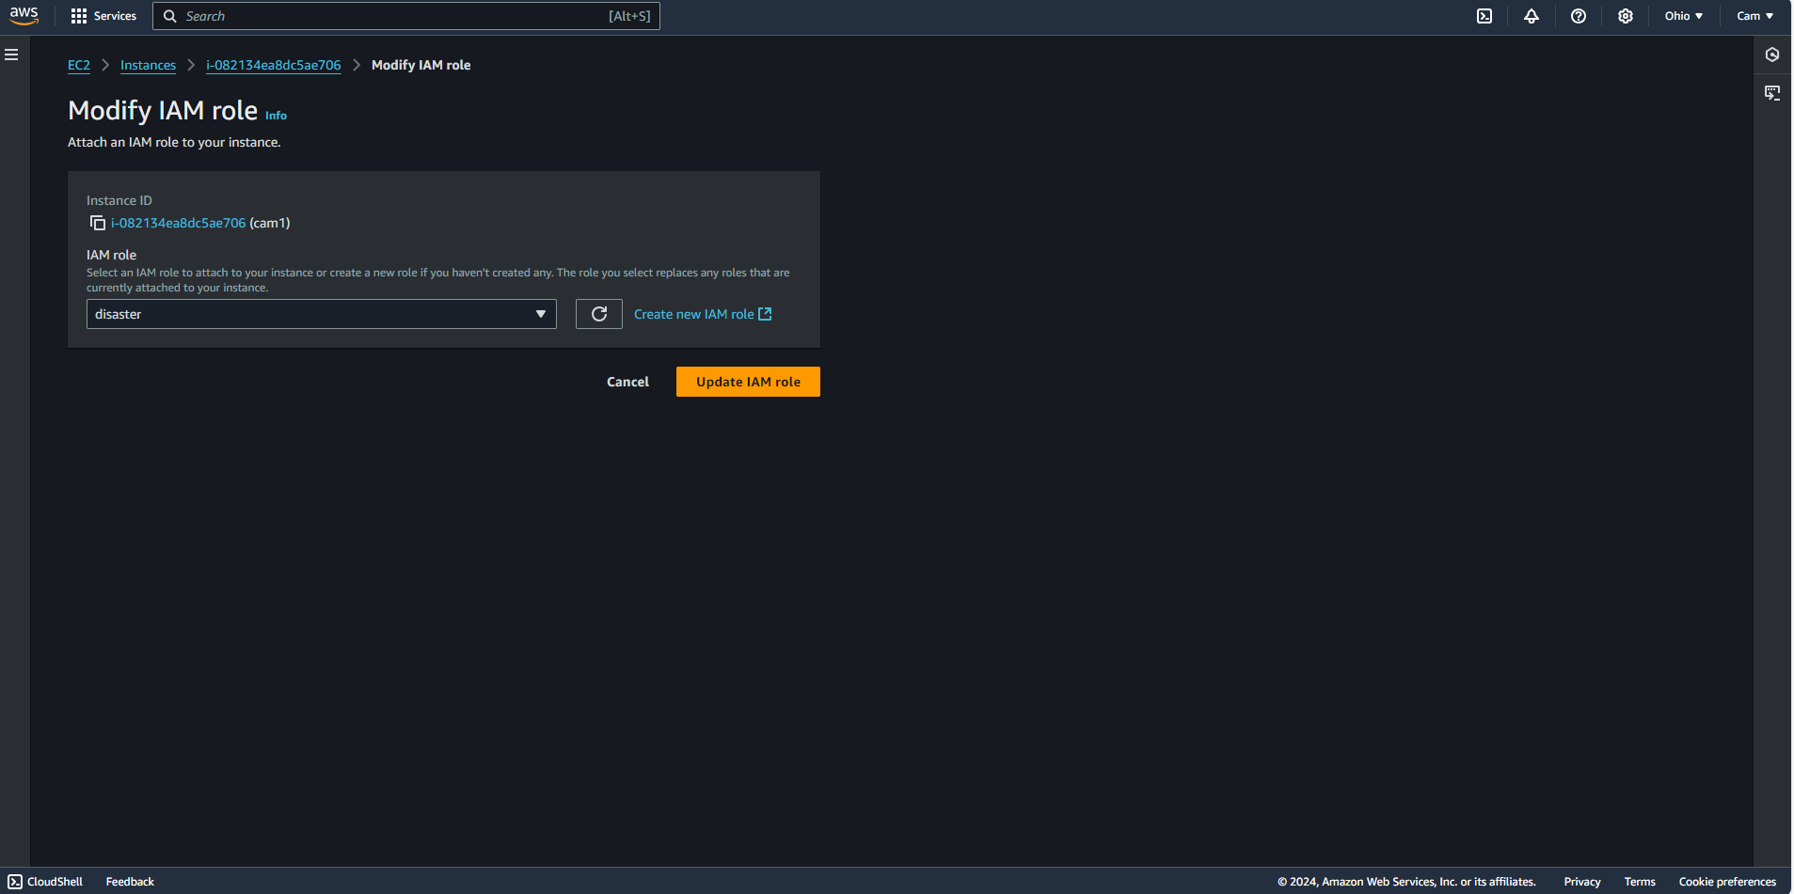

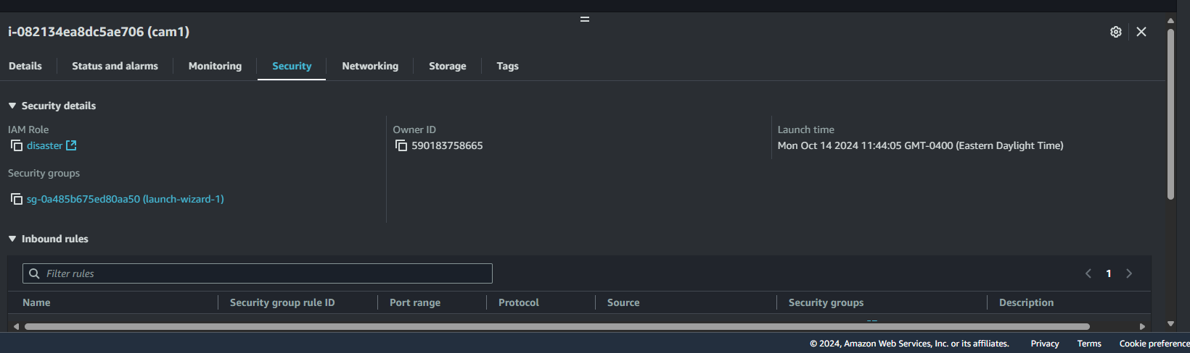

**Figure *16*: IAM role attached to ec2**

Description of IAM role attached:

* Here is a screenshot of the IAM role being attached to my ec2.

Connecting EC2 instance

**Figure *17*: EC2 instance**

Description of ec2 connection:

* Here is a screenshot of me connecting my ec2 instance with the agent policy

Amazon Linux

**Figure *18*: Amazon Linux**

Description of Amazon Linux:

* Here is a screenshot of me using Amazon Linux to install the replication agent

Amazon Linux Command prompt

**Figure *19*: Amazon Linux Command prompt**

Description of Amazon Linux command prompt:

* I have typed in sudo -i so I can root the replication agent to my EC2.

Amazon Linux Command prompt files

**Figure *20*: Amazon Linux Command prompt files**

Description of Amazon Linux command prompt files:

* I have typed in ll to showcase the files installed on ec2. It will be 0 because no files/policies have been installed.

Amazon Linux Command instructions

**Figure *21*: Amazon Linux Command Instructions**

Description of Amazon Linux command instructions:

* Here you can see how I will install my replication agent to my Linux server. The prompt you see in the screenshot is on the Amazon website.

Amazon Linux Replication prompt

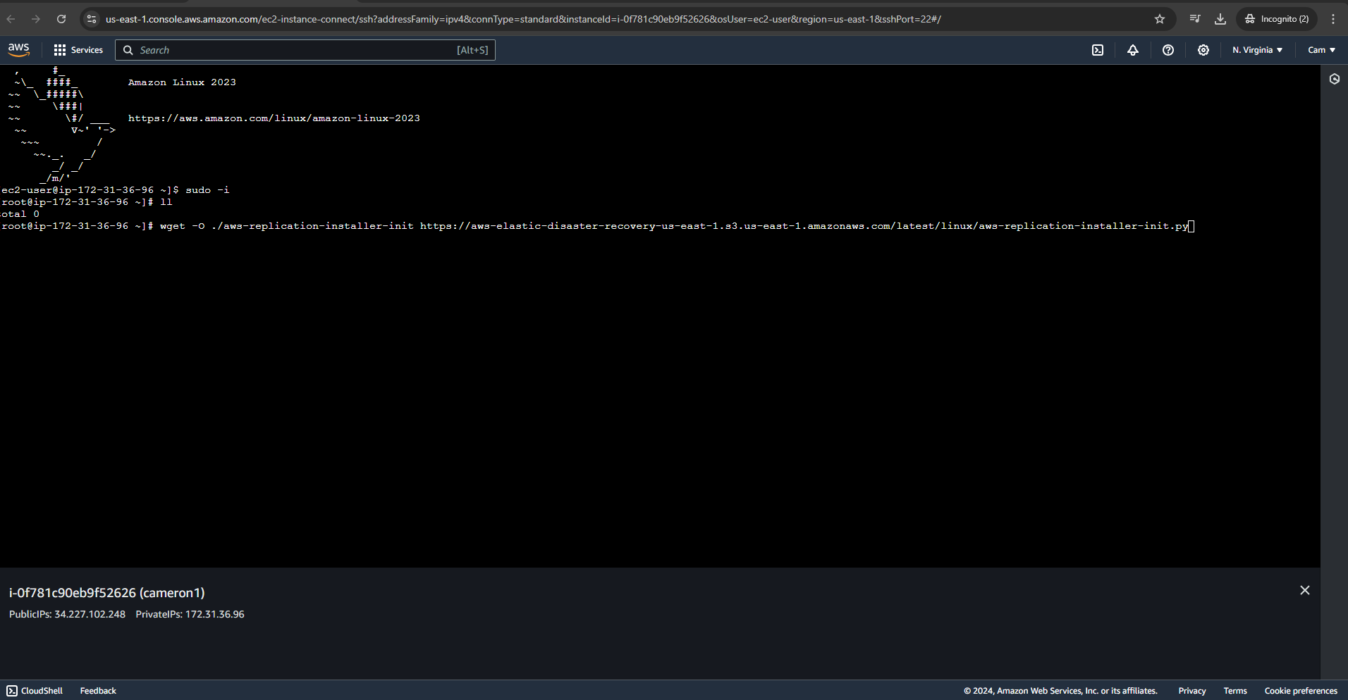

**Figure *22*: Amazon Linux Replication Prompt**

Description of Amazon Linux Replication prompt:

* Here you can see the replication prompt command into my Linux server.

Amazon Linux Replication prompt successfully

**Figure *23*: Amazon Linux Replication Prompt Successfully**

Description of Amazon Linux Replication prompt successfully:

* I have now installed the replication agent prompt successfully.

Amazon Linux Replication prompt files

**Figure *24*: Amazon Linux Replication Prompt Files**

Description of Amazon Linux Replication prompt files:

* As before you can see there were no files installed but now I have installed files. You can see that there is a total of 36 files installed.

Amazon Linux Replication Installation into region/ec2

**Figure *25*: Amazon Linux Replication installation into region/ec2**

Description of Amazon Linux Replication installation region:

* Here is where you will see me pinging the agent to my ec2 instance into the same region. Using the chmod +x aws-replication-installer-init; sudo ./aws-replication-installer-init command

Amazon Linux Replication Agent started

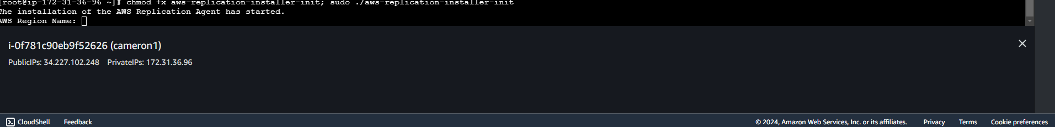

**Figure *26*: Amazon Linux Replication agent**

Description of Amazon Linux Replication agent started:

* Here is where you will see the prompt saying that the replication agent has started. You will see that I must enter an agent name an Agent region name and next will show to enter the access key id and secret key id.

Amazon Linux Replication Access key:

**Figure *27*: Amazon Linux Replication agent access keys**

Description of Amazon Linux Replication agent access keys:

* Now you have seen where I have inserted my access key id and secret access key. It was given to me for when I have created it before in previous screenshots.

Amazon Linux Replicating Disk via Linux

**Figure *28*: Amazon Linux Replicating Disk via Linux**

Description of Amazon Linux Replicating Disk via Linux:

I must replicate the disk via Linux. I will press ENTER to replicate all disk

Roadblock: Installing Agent failed



**Figure *29*: Roadblock**

Description of Roadblock:

I do not have the minimum required storage to install the agent. I must increase my disk space to 500MB in order to install the replication agent.

Roadblock Resolution: Changing Instance type storage



**Figure *30*: Roadblock Resolution**

Description of Roadblock:

I needed to change my storage that was implanted on my ec2. Originally, I use a free tier eligible which was a t2.micro with 1 GB and 475 MB. I have now changed the storage to a t2.large which has 8GB and 500+ MB. The minimum requirement for installing the agent needs to be 8GB and 500MB.

Installing Replication agent Successfully

**Figure *31*: Installing replication agent successfully**

Description of installing replication agent successfully:

Once I changed my storage to my ec2 instance. I am now successfully in installing the replication agent to my ec2.

Adding my ec2 to disaster recovery source server

**Figure *32*: Source server**

Description of Source server:

Above you see the replication agent added to my source server which is needed to replicate my disaster recovery console to my AWS.

Elastic disaster recovery replication server added to instance

**Figure *33*: Replication Server added to instance**

Description of Replication server added to instance:

Above you see another instance that was created. This instance is the AWS elastic replication server. It is needed to run the disaster recovery successfully. To do this successfully, they both must be running.

Initiating recovery drill

**Figure *34*: Recovery drill**

Description of Recovery drill:

I will run a formal disaster recovery drill to validate the drill section of the disaster recovery plan and to make sure nothing was missed during implementation.

Recovery drill Status

**Figure *35*: Recovery status**

Description of Recovery status:

Here you see that the recovery drill is successful, and everything is healthy to run a successful recovery job.

Initiating recovery job

**Figure *36*: Recovery job**

Description of Recovery job:

In this screenshot, I will be initiating the recovery job.

Recovery job successful

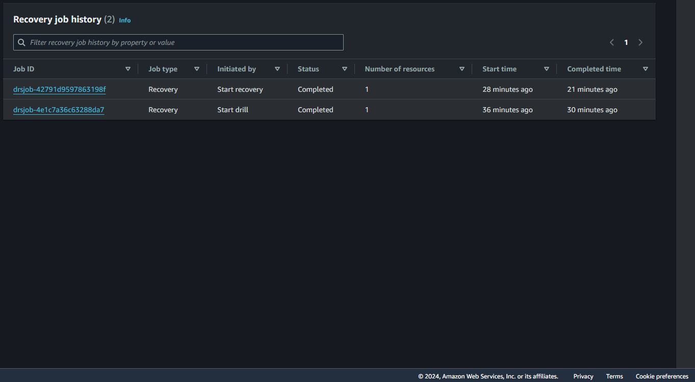

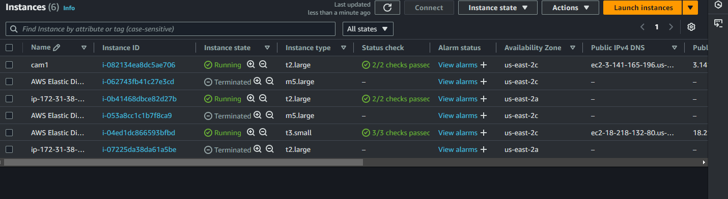

**Figure *37*: Recovery job successful**

Description of Recovery job successful:

Here you see 3 screenshots of the recovery job that was successful and completed. In the last screenshot, you now see 3 instances that are running. When I started the recovery job, the most recent instance that was added is the ip-172-31-38-60 and it is now running. This shows that the disaster recovery is still running and is successful doing so. As you can see the job history of snapshots being taken and finishing snapshots. Same as conversion needed to set up the recovery tool.